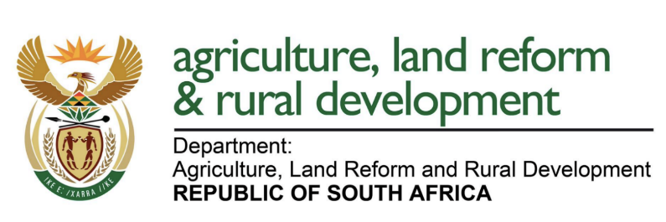
REPUBLIC OF SOUTH AFRICA
DEPARTMENT OF AGRICULTURE, LAND REFORM AND RURAL DEVELOPMENT
FORM A
APPLICATION FOR RENEWAL OF REGISTRATION OF AGRICULTURAL REMEDIES 2024/2027
FERTILIZERS, FARM FEEDS, AGRICULTURAL REMEDIES AND STOCK REMEDIES ACT, 1947 (ACT NO, 36 OF 1947)

Name of the applicant
Address of the applicant

Please indicate in the table below each product that is to be renewed during the relevant renewal period.
Registration number (L number) | Registered tradename of agricultural remedy | Indicate whether this remedy is considered a substance of concern | Indicate whether new scientific evidence is available for vulnerable groups | Indicate whether any adverse reactions have been reported in the last 3 years of registration | Indicate whether any reports of harmful of unacceptable effects have been reported in the last 3 years of registration | Indicate whether the remedy is presently being marketed? | Indicate whether marketing is pending / secret | Indicate whether the remedy is not being marketed under its own label

FEES PAYABLE:
Renewals (submitted before 31 May): | R 6 468.00 x 1 = | R 6 468.00 / product
Late renewals (submitted between 1 June and 30 June): | R 6 468.00 + R 4 515.00 = | R 10 983.00 / product

FOR OFFICIAL USE ONLY
This is to certify that the registration of the agricultural remedies listed on this form have been renewed and are valid until 31 May 2027.
Checked |  | Date
REGISTRAR: ACT NO. 36 OF 1947

